ANDROID APP DEVELOPMENT
In this notes, i will create a full android tutorial from three areas
1. Native Android App
2. React Native
3. Flutter App

Native Android App Tutorial
The android package name must be unique for every application in the world for your application will be identified by it package name

The API LEVEL you will select will determine which minimum device can use your application

You can select an empty activity or no activity at all

Also we can drag and drop objects to create our application in the activity.xml file or we can code it in the xml
example of the xml is

activity_main.xml
<?xml version="1.0" encoding="utf-8"?>
<androidx.constraintlayout.widget.ConstraintLayout xmlns:android="http://schemas.android.com/apk/res/android"
xmlns:app="http://schemas.android.com/apk/res-auto"
xmlns:tools="http://schemas.android.com/tools"
android:layout_width="match_parent"
android:layout_height="match_parent"
tools:context=".MainActivity">
<TextView
android:id="@+id/textView"
android:layout_width="wrap_content"
android:layout_height="wrap_content"
android:text="Hydot Money is Here"
app:layout_constraintBottom_toBottomOf="parent"
app:layout_constraintEnd_toEndOf="parent"
app:layout_constraintStart_toStartOf="parent"
app:layout_constraintTop_toTopOf="parent" />
<com.google.android.material.floatingactionbutton.FloatingActionButton
android:id="@+id/floatingActionButton2"
android:layout_width="wrap_content"
android:layout_height="wrap_content"
android:clickable="true"
app:layout_constraintBottom_toBottomOf="parent"
app:layout_constraintEnd_toEndOf="parent"
app:layout_constraintHorizontal_bias="0.873"
app:layout_constraintStart_toStartOf="parent"
app:layout_constraintTop_toBottomOf="@+id/textView"
app:layout_constraintVertical_bias="0.85"
app:srcCompat="@android:drawable/alert_dark_frame" />
</androidx.constraintlayout.widget.ConstraintLayout>
After running the code, it will appear like this
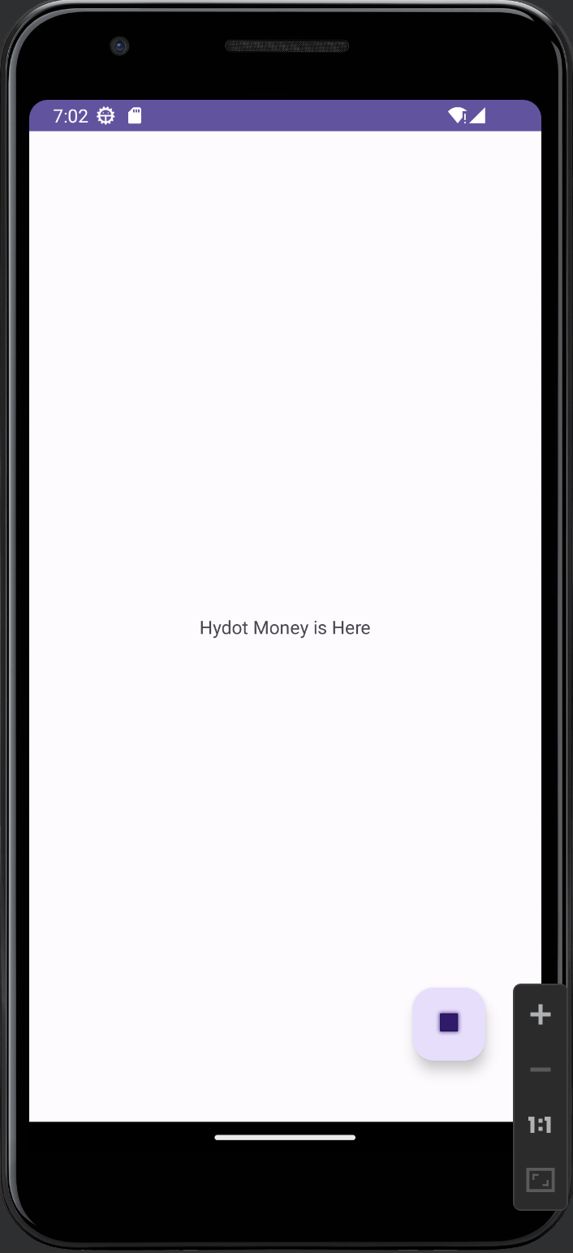

The TextView in the xml file must contain an id so the we can access that particular ID in the Java section

The activity_main.xml will contain the application UI and the MainActivity.java will contain the logic of the App

A function that changes a text
In the xml file, add this android:onClick="onBtnClick"
In the MainActivity.java, add this

package com.hydotgroup.flexiisecure;
import androidx.appcompat.app.AppCompatActivity;
import android.os.Bundle;
import android.view.View;
import android.widget.TextView;
public class MainActivity extends AppCompatActivity {
@Override
protected void onCreate(Bundle savedInstanceState) {
super.onCreate(savedInstanceState);
setContentView(R.layout.activity_main);
}
public void onBtnClick(View view){
TextView txtHello = findViewById(R.id.textHydot);
txtHello.setText("Hello Dollars Man");
}
}

User Inputs
1. Drag and drop the plain text widgets into the application project
2. Move to the custome attributes section of the design section of the xml appliication and give the text a hint also give the text an ID
3. Move to the main activity section, and use the id to add functionality
package com.hydotgroup.flexiisecure;
import androidx.appcompat.app.AppCompatActivity;
import android.os.Bundle;
import android.view.View;
import android.widget.EditText;
import android.widget.TextView;
public class MainActivity extends AppCompatActivity {
@Override
protected void onCreate(Bundle savedInstanceState) {
super.onCreate(savedInstanceState);
setContentView(R.layout.activity_main);
}
public void onBtnClick(View view){
TextView txtHello = findViewById(R.id.textHydot);
EditText name = findViewById(R.id.editName);
txtHello.setText("Hello "+name.getText().toString()+" Welcome");
}
}

Challenge 1
Create a Basic Sign Up Form

Solutions
activity_main.xml
<?xml version="1.0" encoding="utf-8"?>
<androidx.constraintlayout.widget.ConstraintLayout xmlns:android="http://schemas.android.com/apk/res/android"
xmlns:app="http://schemas.android.com/apk/res-auto"
xmlns:tools="http://schemas.android.com/tools"
android:layout_width="match_parent"
android:layout_height="match_parent"
tools:context=".MainActivity">
<EditText
android:id="@+id/firstname"
android:layout_width="wrap_content"
android:layout_height="wrap_content"
android:ems="10"
android:hint="First Name"
android:inputType="text"
app:layout_constraintBottom_toBottomOf="parent"
app:layout_constraintEnd_toEndOf="parent"
app:layout_constraintHorizontal_bias="0.373"
app:layout_constraintStart_toStartOf="parent"
app:layout_constraintTop_toTopOf="parent"
app:layout_constraintVertical_bias="0.309" />
<TextView
android:id="@+id/textView2"
android:layout_width="164dp"
android:layout_height="30dp"
android:layout_marginBottom="84dp"
android:text=" Signup Now"
app:layout_constraintBottom_toTopOf="@+id/firstname"
app:layout_constraintEnd_toEndOf="parent"
app:layout_constraintHorizontal_bias="0.36"
app:layout_constraintStart_toStartOf="parent"
app:layout_constraintTop_toTopOf="parent"
app:layout_constraintVertical_bias="1.0" />
<EditText
android:id="@+id/lastname"
android:layout_width="wrap_content"
android:layout_height="wrap_content"
android:ems="10"
android:hint="Last Name"
android:inputType="text"
app:layout_constraintBottom_toBottomOf="parent"
app:layout_constraintEnd_toEndOf="parent"
app:layout_constraintHorizontal_bias="0.368"
app:layout_constraintStart_toStartOf="parent"
app:layout_constraintTop_toTopOf="parent"
app:layout_constraintVertical_bias="0.419" />
<EditText
android:id="@+id/email"
android:layout_width="wrap_content"
android:layout_height="wrap_content"
android:ems="10"
android:hint="name@example.com"
android:inputType="textEmailAddress"
app:layout_constraintBottom_toBottomOf="parent"
app:layout_constraintEnd_toEndOf="parent"
app:layout_constraintHorizontal_bias="0.373"
app:layout_constraintStart_toStartOf="parent"
app:layout_constraintTop_toTopOf="parent" />
<Button
android:id="@+id/registerbutton"
android:layout_width="wrap_content"
android:layout_height="wrap_content"
android:onClick="register"
android:text="Register"
app:layout_constraintBottom_toBottomOf="parent"
app:layout_constraintEnd_toEndOf="parent"
app:layout_constraintHorizontal_bias="0.419"
app:layout_constraintStart_toStartOf="parent"
app:layout_constraintTop_toTopOf="parent"
app:layout_constraintVertical_bias="0.617" />
<TextView
android:id="@+id/firstnameDisplay"
android:layout_width="328dp"
android:layout_height="40dp"
android:text="Firstname"
app:layout_constraintBottom_toBottomOf="parent"
app:layout_constraintEnd_toEndOf="parent"
app:layout_constraintHorizontal_bias="0.373"
app:layout_constraintStart_toStartOf="parent"
app:layout_constraintTop_toTopOf="parent"
app:layout_constraintVertical_bias="0.714" />
<TextView
android:id="@+id/lastnameDisplay"
android:layout_width="321dp"
android:layout_height="35dp"
android:text="Lastname"
app:layout_constraintBottom_toBottomOf="parent"
app:layout_constraintEnd_toEndOf="parent"
app:layout_constraintHorizontal_bias="0.343"
app:layout_constraintStart_toStartOf="parent"
app:layout_constraintTop_toTopOf="parent"
app:layout_constraintVertical_bias="0.786" />
<TextView
android:id="@+id/emailDisplay"
android:layout_width="317dp"
android:layout_height="34dp"
android:text="Email "
app:layout_constraintBottom_toBottomOf="parent"
app:layout_constraintEnd_toEndOf="parent"
app:layout_constraintHorizontal_bias="0.358"
app:layout_constraintStart_toStartOf="parent"
app:layout_constraintTop_toTopOf="parent"
app:layout_constraintVertical_bias="0.888" />
</androidx.constraintlayout.widget.ConstraintLayout>
MainActivity.java
package com.hydotgroup.flexiisecure;
import androidx.appcompat.app.AppCompatActivity;
import android.annotation.SuppressLint;
import android.os.Bundle;
import android.view.View;
import android.widget.EditText;
import android.widget.TextView;
public class MainActivity extends AppCompatActivity {
@Override
protected void onCreate(Bundle savedInstanceState) {
super.onCreate(savedInstanceState);
setContentView(R.layout.activity_main);

}
public void register(View view){
EditText FirstName = findViewById(R.id.firstname);
EditText LastName = findViewById(R.id.lastname);
EditText email = findViewById(R.id.email);
TextView firstdis = findViewById(R.id.firstnameDisplay);
TextView lastdis = findViewById(R.id.lastnameDisplay);
TextView emaildis = findViewById(R.id.emailDisplay);
firstdis.setText(FirstName.getText().toString());
lastdis.setText(LastName.getText().toString());
emaildis.setText(email.getText().toString());
}
}
Solution Picture

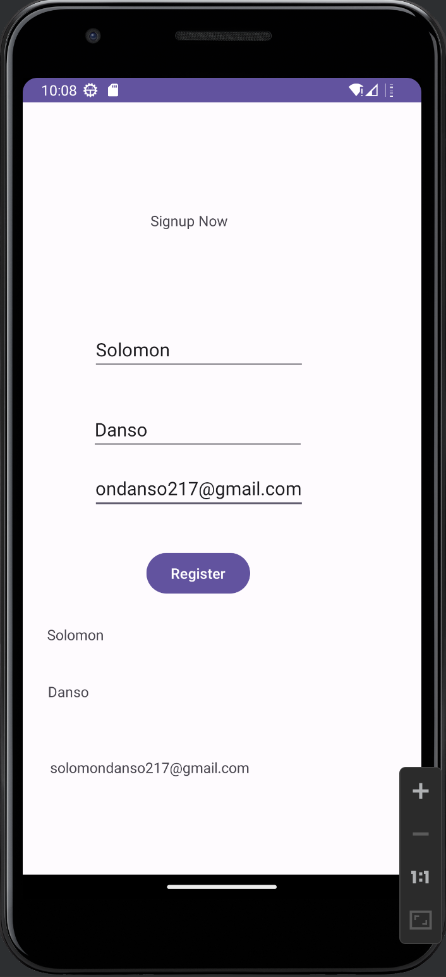
USER INTERFACE
In the app/res/values/colors.xml, we can define our own colors we are going to use for our projects
<?xml version="1.0" encoding="utf-8"?>
<resources>
<color name="black">#FF000000</color>
<color name="white">#FFFFFFFF</color>
<color name="orange">#f06040</color>
</resources>
To get the Hexadecimal value for the color, we can use html color picker tool online
The ID should be unique for every xml object
<?xml version="1.0" encoding="utf-8"?>
<RelativeLayout xmlns:android="http://schemas.android.com/apk/res/android"
xmlns:app="http://schemas.android.com/apk/res-auto"
xmlns:tools="http://schemas.android.com/tools"
android:layout_width="match_parent"
android:layout_height="match_parent"
tools:context=".MainActivity">
<TextView
android:layout_width="wrap_content"
android:layout_height="wrap_content"
android:text="Hydot Money is here"
android:layout_centerInParent="true"
android:textSize="20sp"
android:textStyle="bold|italic"
android:textColor="@color/orange"
android:id="@+id/textWelcome" />
<Button
android:layout_width="wrap_content"
android:layout_height="wrap_content"
android:text="Money"
android:layout_below="@+id/textWelcome"
android:layout_centerHorizontal="true"
android:layout_marginTop="15dp"
android:backgroundTint="@color/orange"
android:textColor="@color/black"
android:textSize="20dp"
android:onClick="buttoner"
/>
</RelativeLayout>

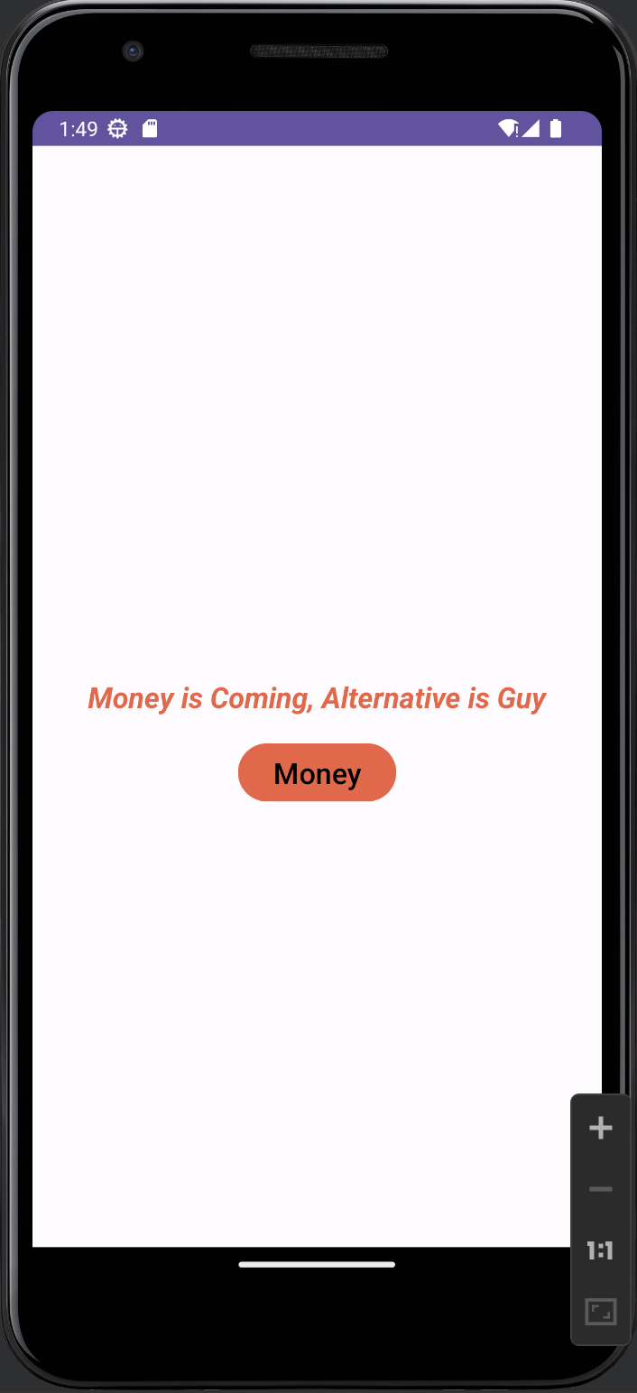

User Interface Part 2

<?xml version="1.0" encoding="utf-8"?>
<RelativeLayout xmlns:android="http://schemas.android.com/apk/res/android"
xmlns:app="http://schemas.android.com/apk/res-auto"
xmlns:tools="http://schemas.android.com/tools"
android:layout_width="match_parent"
android:layout_height="match_parent"
android:padding="100dp"
tools:context=".MainActivity">
<EditText
android:id="@+id/editName"
android:layout_width="match_parent"
android:layout_height="wrap_content"
android:layout_centerInParent="true"
android:fontFamily="serif-monospace"
android:hint="Name"
android:inputType="textAutoCorrect"
android:lines="2"
android:textColor="@color/orange"
android:textStyle="bold"
/>
<Button
android:id="@+id/buttonId"
android:layout_width="wrap_content"
android:layout_height="wrap_content"
android:layout_below="@+id/editName"
android:layout_centerHorizontal="true"
android:layout_marginTop="20dp"
android:backgroundTint="@color/black"
android:text="Say Hello"
android:textSize="20dp" />
<TextView
android:id="@+id/textName"
android:layout_width="wrap_content"
android:layout_height="wrap_content"
android:layout_below="@+id/buttonId"
android:layout_centerHorizontal="true"
android:layout_marginTop="20dp"
android:text="Name"
android:textColor="@color/black"
android:textSize="30dp"
/>
</RelativeLayout>
package com.hydotgroup.flexiisecure;
import android.os.Bundle;
import android.view.View;
import android.widget.Button;
import android.widget.EditText;
import android.widget.TextView;
import android.widget.Toast;
import androidx.appcompat.app.AppCompatActivity;
public class MainActivity extends AppCompatActivity implements View.OnClickListener{
private EditText editName;
private TextView textName;
@Override
public void onClick(View src) {
int id = src.getId();
if(id == R.id.buttonId){
Toast.makeText(this, "Hydot Money is Money", Toast.LENGTH_SHORT).show();
textName.setText(editName.getText().toString());
} else if (id==R.id.textName) {
textName.setText(editName.getText().toString().toUpperCase());
}
}
@Override
protected void onCreate(Bundle savedInstanceState) {
super.onCreate(savedInstanceState);
setContentView(R.layout.activity_main);
Button btn = findViewById(R.id.buttonId);
//The setOnClickListener will call the onClick method above
btn.setOnClickListener(this);
editName = findViewById(R.id.editName);
textName = findViewById(R.id.textName);
textName.setOnClickListener(this);
}
}

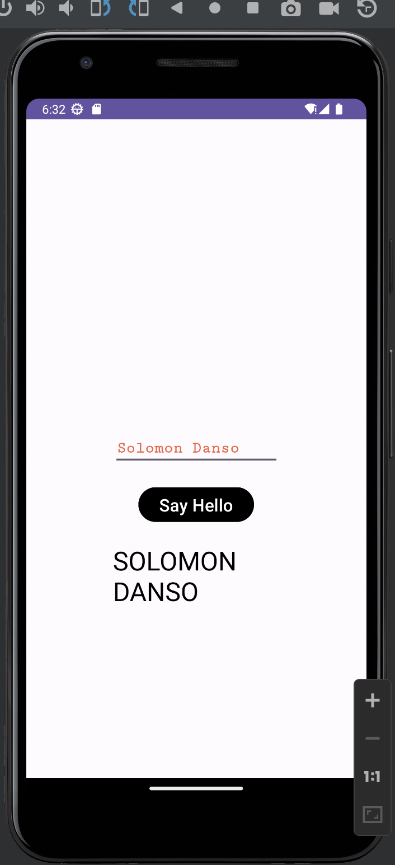

User Interface Part 3 (checked boxes)
<?xml version="1.0" encoding="utf-8"?>
<RelativeLayout xmlns:android="http://schemas.android.com/apk/res/android"
xmlns:app="http://schemas.android.com/apk/res-auto"
xmlns:tools="http://schemas.android.com/tools"
android:layout_width="match_parent"
android:layout_height="match_parent"
android:padding="10dp"
tools:context=".MainActivity">

<RelativeLayout
android:layout_width="wrap_content"
android:layout_height="wrap_content"
android:id="@+id/moviesLayout"
android:layout_centerHorizontal="true"
android:layout_marginTop="20dp"
>
<CheckBox
android:layout_width="wrap_content"
android:layout_height="wrap_content"
android:text="Harry"
android:id="@+id/checkMovie1"
android:checked="true"
/>
<CheckBox
android:layout_width="wrap_content"
android:layout_height="wrap_content"
android:text="Kofi"
android:id="@+id/checkMovie2"
android:checked="true"
android:layout_toRightOf="@+id/checkMovie1"
android:layout_marginLeft="1dp"
/>
<CheckBox
android:id="@+id/checkMovie3"
android:layout_width="wrap_content"
android:layout_height="wrap_content"
android:layout_toRightOf="@+id/checkMovie2"
android:checked="false"
android:text="Kwame"
/>
</RelativeLayout>

</RelativeLayout>
package com.hydotgroup.flexiisecure;
import android.os.Bundle;
import android.view.View;
import android.widget.Button;
import android.widget.CheckBox;
import android.widget.CompoundButton;
import android.widget.EditText;
import android.widget.TextView;
import android.widget.Toast;
import androidx.appcompat.app.AppCompatActivity;
public class MainActivity extends AppCompatActivity {
private CheckBox check1;
private CheckBox check2;
private CheckBox check3;
@Override
protected void onCreate(Bundle savedInstanceState) {
super.onCreate(savedInstanceState);
setContentView(R.layout.activity_main);
check1 = findViewById(R.id.checkMovie1);
check2 = findViewById(R.id.checkMovie2);
check3 = findViewById(R.id.checkMovie3);

//Check whether the check 1 is selected by default
if(check1.isChecked()){
Toast.makeText(this, "You Love the movie alreeady erh father Harry", Toast.LENGTH_LONG).show();
}
else{
Toast.makeText(this, "Shame on you Aunty Harry", Toast.LENGTH_SHORT).show();
}

//Run when the user checks or not
check1.setOnCheckedChangeListener(new CompoundButton.OnCheckedChangeListener() {
@Override
public void onCheckedChanged(CompoundButton buttonView, boolean isChecked) {
if(isChecked){
Toast.makeText(MainActivity.this, "Hello do you want to watch Harry Potter Moviie", Toast.LENGTH_SHORT).show();
}
else{
Toast.makeText(MainActivity.this, "Okay i understand you dont want to watch Harry Potter", Toast.LENGTH_SHORT).show();
}
}
});
}
}
By typing only this check1.setOnCheckedChangeListener, everything will be set

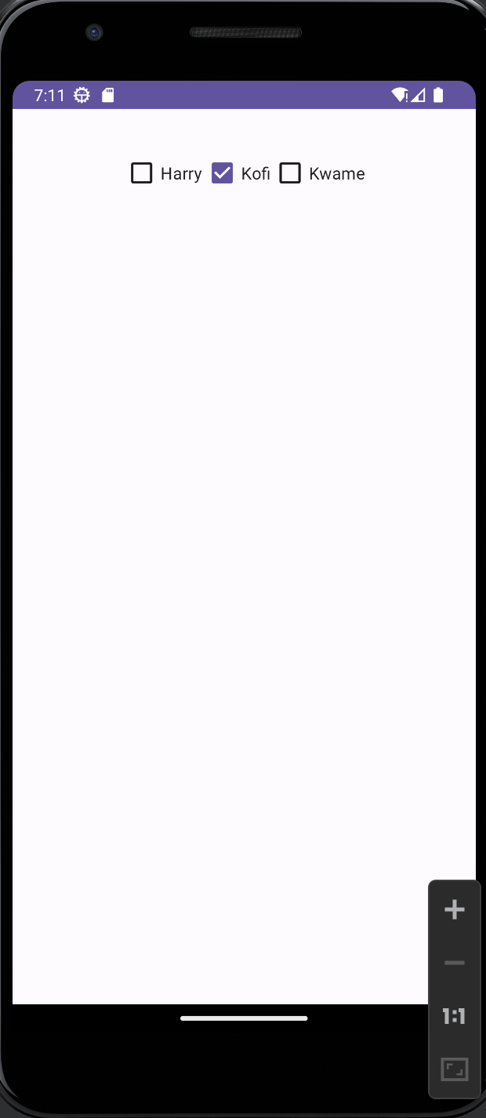

User Interface Radio Button

<?xml version="1.0" encoding="utf-8"?>
<RelativeLayout xmlns:android="http://schemas.android.com/apk/res/android"
xmlns:app="http://schemas.android.com/apk/res-auto"
xmlns:tools="http://schemas.android.com/tools"
android:layout_width="match_parent"
android:layout_height="match_parent"
android:padding="10dp"
tools:context=".MainActivity">

<RelativeLayout
android:layout_width="wrap_content"
android:layout_height="wrap_content"
android:id="@+id/moviesLayout"
android:layout_centerHorizontal="true"
android:layout_marginTop="20dp"
>
<CheckBox
android:layout_width="wrap_content"
android:layout_height="wrap_content"
android:text="Harry"
android:id="@+id/checkMovie1"
android:checked="true"
/>
<CheckBox
android:layout_width="wrap_content"
android:layout_height="wrap_content"
android:text="Kofi"
android:id="@+id/checkMovie2"
android:checked="true"
android:layout_toRightOf="@+id/checkMovie1"
android:layout_marginLeft="1dp"
/>
<CheckBox
android:id="@+id/checkMovie3"
android:layout_width="wrap_content"
android:layout_height="wrap_content"
android:layout_toRightOf="@+id/checkMovie2"
android:checked="false"
android:text="Kwame"
/>
</RelativeLayout>

<RadioGroup
android:layout_width="wrap_content"
android:layout_height="wrap_content"
android:layout_below="@+id/moviesLayout"
android:layout_marginTop="20dp"
android:layout_centerHorizontal="true"
android:orientation="horizontal"
android:id="@+id/radioSelector"
>
<RadioButton
android:layout_width="wrap_content"
android:layout_height="wrap_content"
android:text="Boy"
android:textSize="20dp"
android:textColor="@color/orange"
android:id="@+id/radioBoy"
android:checked="true"
/>
<RadioButton
android:layout_width="wrap_content"
android:layout_height="wrap_content"
android:text="Girl"
android:textSize="20dp"
android:textColor="@color/orange"
android:id="@+id/radioGirl"
android:layout_marginLeft="15dp"
/>
<RadioButton
android:layout_width="wrap_content"
android:layout_height="wrap_content"
android:text="Hemaphrodite"
android:textColor="@color/orange"
android:textSize="20dp"
android:id="@+id/hema"
android:layout_marginLeft="15dp"
/>
</RadioGroup>
</RelativeLayout>
package com.hydotgroup.flexiisecure;
import android.os.Bundle;
import android.view.View;
import android.widget.Button;
import android.widget.CheckBox;
import android.widget.CompoundButton;
import android.widget.EditText;
import android.widget.RadioGroup;
import android.widget.TextView;
import android.widget.Toast;
import androidx.appcompat.app.AppCompatActivity;
public class MainActivity extends AppCompatActivity {
private CheckBox check1;
private CheckBox check2;
private CheckBox check3;
private RadioGroup radioGroupSelector;
@Override
protected void onCreate(Bundle savedInstanceState) {
super.onCreate(savedInstanceState);
setContentView(R.layout.activity_main);
check1 = findViewById(R.id.checkMovie1);
check2 = findViewById(R.id.checkMovie2);
check3 = findViewById(R.id.checkMovie3);
radioGroupSelector = findViewById(R.id.radioSelector);
radioGroupSelector.setOnCheckedChangeListener(new RadioGroup.OnCheckedChangeListener() {
@Override
public void onCheckedChanged(RadioGroup group, int checkedId) {
if(checkedId==R.id.radioBoy){
Toast.makeText(MainActivity.this, "Hey Boy", Toast.LENGTH_SHORT).show();
} else if (checkedId==R.id.radioGirl) {
Toast.makeText(MainActivity.this, "Hey Girl", Toast.LENGTH_SHORT).show();
}
else {
Toast.makeText(MainActivity.this, "Hey You All", Toast.LENGTH_SHORT).show();
}
}
});
//Check whether the check 1 is selected by default
if(check1.isChecked()){
Toast.makeText(this, "You Love the movie alreeady erh father Harry", Toast.LENGTH_LONG).show();
}
else{
Toast.makeText(this, "Shame on you Aunty Harry", Toast.LENGTH_SHORT).show();
}
//Run when the user checks or not
check1.setOnCheckedChangeListener(new CompoundButton.OnCheckedChangeListener() {
@Override
public void onCheckedChanged(CompoundButton buttonView, boolean isChecked) {
if(isChecked){
Toast.makeText(MainActivity.this, "Hello do you want to watch Harry Potter Moviie", Toast.LENGTH_SHORT).show();
}
else{
Toast.makeText(MainActivity.this, "Okay i understand you dont want to watch Harry Potter", Toast.LENGTH_SHORT).show();
}
}
});
}
}
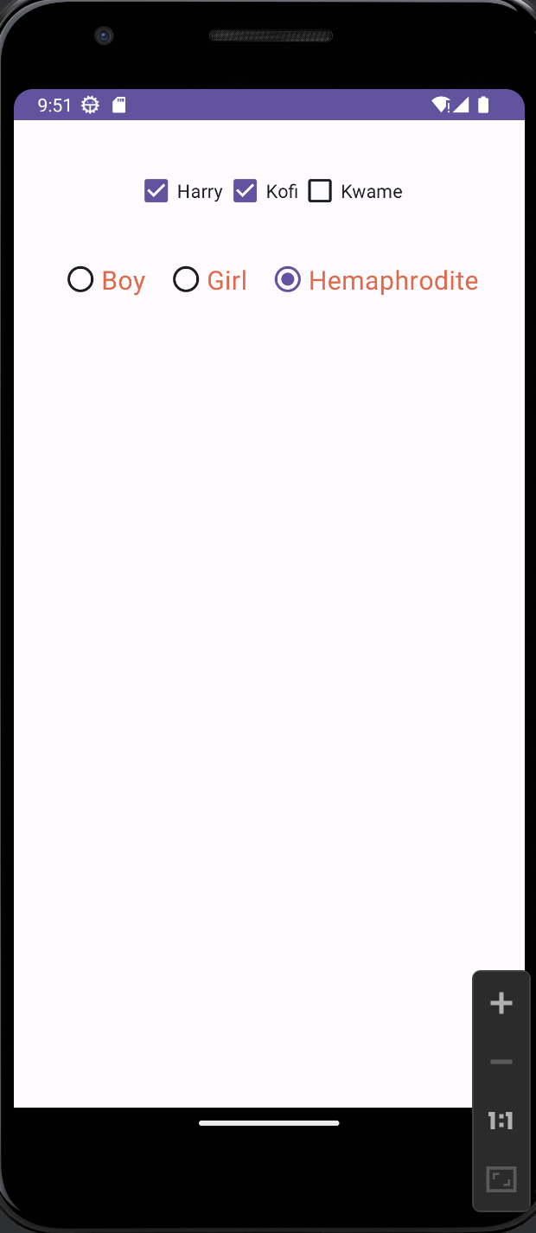

User Interface Progress Bar

<?xml version="1.0" encoding="utf-8"?>
<RelativeLayout xmlns:android="http://schemas.android.com/apk/res/android"
xmlns:app="http://schemas.android.com/apk/res-auto"
xmlns:tools="http://schemas.android.com/tools"
android:layout_width="match_parent"
android:layout_height="match_parent"
android:padding="10dp"
tools:context=".MainActivity">

<RelativeLayout
android:layout_width="wrap_content"
android:layout_height="wrap_content"
android:id="@+id/moviesLayout"
android:layout_centerHorizontal="true"
android:layout_marginTop="20dp"
>
<CheckBox
android:layout_width="wrap_content"
android:layout_height="wrap_content"
android:text="Harry"
android:id="@+id/checkMovie1"
android:checked="true"
/>
<CheckBox
android:layout_width="wrap_content"
android:layout_height="wrap_content"
android:text="Kofi"
android:id="@+id/checkMovie2"
android:checked="true"
android:layout_toRightOf="@+id/checkMovie1"
android:layout_marginLeft="1dp"
/>
<CheckBox
android:id="@+id/checkMovie3"
android:layout_width="wrap_content"
android:layout_height="wrap_content"
android:layout_toRightOf="@+id/checkMovie2"
android:checked="false"
android:text="Kwame"
/>
</RelativeLayout>

<RadioGroup
android:layout_width="wrap_content"
android:layout_height="wrap_content"
android:layout_below="@+id/moviesLayout"
android:layout_marginTop="20dp"
android:layout_centerHorizontal="true"
android:orientation="horizontal"
android:id="@+id/radioSelector"
>
<RadioButton
android:layout_width="wrap_content"
android:layout_height="wrap_content"
android:text="Boy"
android:textSize="20dp"
android:textColor="@color/orange"
android:id="@+id/radioBoy"
android:checked="true"
/>
<RadioButton
android:layout_width="wrap_content"
android:layout_height="wrap_content"
android:text="Girl"
android:textSize="20dp"
android:textColor="@color/orange"
android:id="@+id/radioGirl"
android:layout_marginLeft="15dp"
/>
<RadioButton
android:layout_width="wrap_content"
android:layout_height="wrap_content"
android:text="Hemaphrodite"
android:textColor="@color/orange"
android:textSize="20dp"
android:id="@+id/hema"
android:layout_marginLeft="15dp"
/>
</RadioGroup>
<ProgressBar
android:layout_width="match_parent"
android:layout_height="wrap_content"
android:id="@+id/loader"
android:layout_centerInParent="true"
android:visibility="visible"
style="@style/Widget.AppCompat.ProgressBar.Horizontal"
android:max="100"
android:layout_marginLeft="20dp"
android:layout_marginRight="20dp"
/>
</RelativeLayout>
package com.hydotgroup.flexiisecure;
import android.os.Bundle;
import android.os.SystemClock;
import android.view.View;
import android.widget.Button;
import android.widget.CheckBox;
import android.widget.CompoundButton;
import android.widget.EditText;
import android.widget.ProgressBar;
import android.widget.RadioGroup;
import android.widget.TextView;
import android.widget.Toast;
import androidx.appcompat.app.AppCompatActivity;
public class MainActivity extends AppCompatActivity {
private CheckBox check1;
private CheckBox check2;
private CheckBox check3;
private RadioGroup radioGroupSelector;
private ProgressBar loader;
@Override
protected void onCreate(Bundle savedInstanceState) {
super.onCreate(savedInstanceState);
setContentView(R.layout.activity_main);
check1 = findViewById(R.id.checkMovie1);
check2 = findViewById(R.id.checkMovie2);
check3 = findViewById(R.id.checkMovie3);
radioGroupSelector = findViewById(R.id.radioSelector);
loader = findViewById(R.id.loader);
Thread thread = new Thread(new Runnable() {
@Override
public void run() {
for (int i = 0; i<10; i++){
loader.incrementProgressBy(10);
SystemClock.sleep(500);
}
}
});
thread.start();
radioGroupSelector.setOnCheckedChangeListener(new RadioGroup.OnCheckedChangeListener() {
@Override
public void onCheckedChanged(RadioGroup group, int checkedId) {
if(checkedId==R.id.radioBoy){
Toast.makeText(MainActivity.this, "Hey Boy", Toast.LENGTH_SHORT).show();
} else if (checkedId==R.id.radioGirl) {
Toast.makeText(MainActivity.this, "Hey Girl", Toast.LENGTH_SHORT).show();
}
else {
Toast.makeText(MainActivity.this, "Hey You All", Toast.LENGTH_SHORT).show();
loader.setVisibility(View.VISIBLE);
}
}
});
//Check whether the check 1 is selected by default
if(check1.isChecked()){
Toast.makeText(this, "You Love the movie alreeady erh father Harry", Toast.LENGTH_LONG).show();
}
else{
Toast.makeText(this, "Shame on you Aunty Harry", Toast.LENGTH_SHORT).show();
}
//Run when the user checks or not
check1.setOnCheckedChangeListener(new CompoundButton.OnCheckedChangeListener() {
@Override
public void onCheckedChanged(CompoundButton buttonView, boolean isChecked) {
if(isChecked){
Toast.makeText(MainActivity.this, "Hello do you want to watch Harry Potter Moviie", Toast.LENGTH_SHORT).show();
}
else{
Toast.makeText(MainActivity.this, "Okay i understand you dont want to watch Harry Potter", Toast.LENGTH_SHORT).show();
}
}
});
}
}

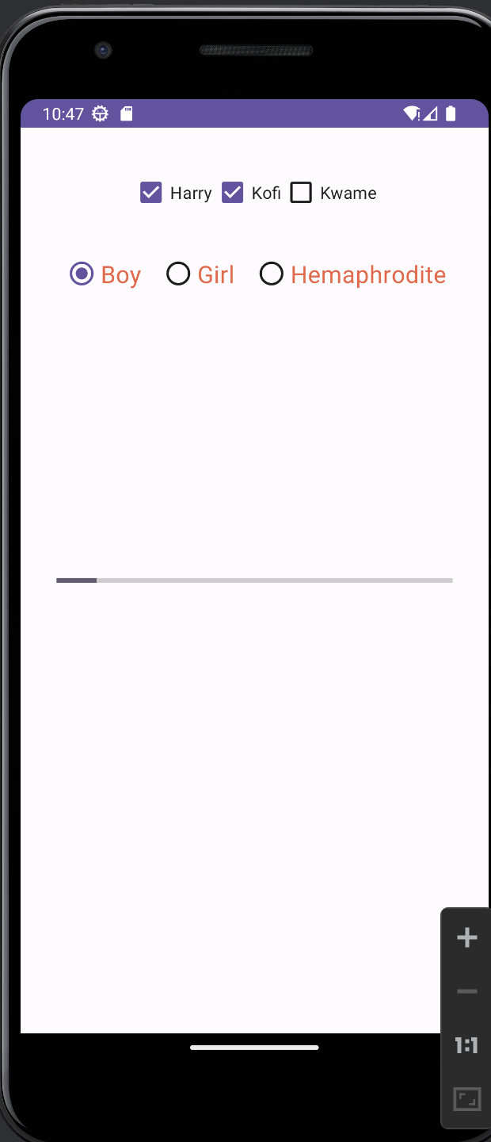

USER INTERFACE LAYOUTS
Relative layout, all the width and height are related to each other

